An Overview of the analytics Dashboard:

An analytics dashboard is a project that showcases the power of a full MERN stack, along with Redux, Material UI and Nivo charts for dynamic data visualization. materialUi for styling material UI data grid for tables,nivo for our charts,redux toolkit for state management ,redux toolkit query for making api calls

In the analytics dashboard, we will have three sections:

1.) Dashboard -:

I will create an analytics dashboard for a customer who is, let's suppose, a pharmacist. In this dashboard, there will be information on how many total customers they have, the total sales of their products, and the sales will be divided into weekly, monthly, and yearly figures. Using Nivo charts, the dashboard will provide an analysis with the help of charts showing the monthly business growth, which will allow us to analyze the growth of the user's business. The dashboard will also contain the user's information, which we will uniquely identify with the help of a customer ID, showing how much each customer has purchased and the total sales we have made with that customer.In the dashboard section, we can also download reports.

2.)Information -:

1.)shop-: In this shop section, we will have some products, and the information about the added products by an admin will include the product's name, type, ID, price, description, overall rating, remaining supply, and yearly sales of that product.

2.)users-:Now, the users section contains a list of customers and information about customers such as customer ID, name, email, phone number, country, occupation, and role. We will be able to view customers with some filters if we have a large number of customers.

3.)money-:This money sections contains the entire list of transactions of an cutomer.In the money section, there will be a track record of the customer showing when they made purchases with the date and time, the total quantity of product they purchased, and the total price of those products.we can download the raw data as csv and also we can take print out also

4.)map-:It provides the geography which contains information about users from all over the world, showing which country our customers belong to and how many customers are from each country.

3.)Internal -:

1.)overview-:In this section, there will be a chart showing our user's monthly sales. Based on this monthly sales data, the user will be able to analyze the business growth through the graph.

2.)daily-:In this section, we will also see the total sales and total units sold on a daily basis. We can view data from previous days as well, showing how many units were sold and the total sales for each day. With the help of the graph, we will analyze the user's daily sales and the number of items sold.

3.)monthly-:In this section, we will see the total sales and the total units sold on a monthly basis. We can observe how many units were sold and the total sales for each month with the help of the graph. This will allow us to analyze the user's monthly sales and the number of items sold.

4.)breakdown-: This can be easily explained with the pictures given below.

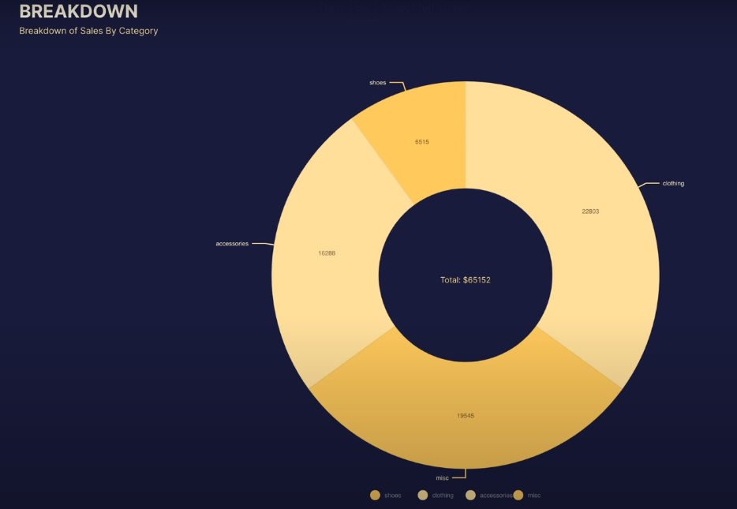

This Completes analytics Dashboard will look like this :

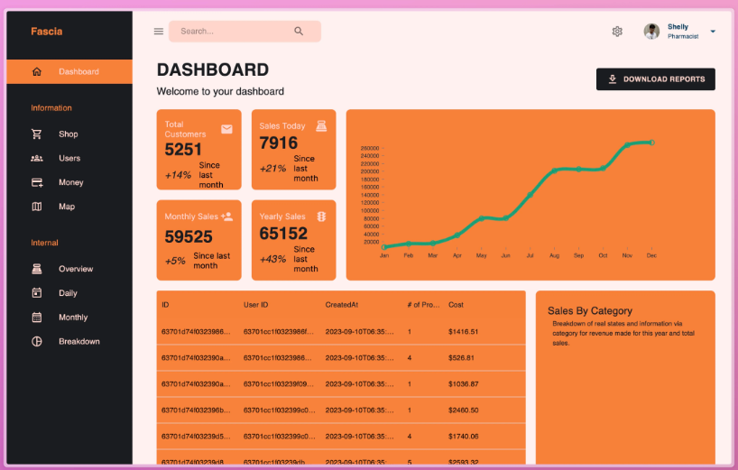

Npm packages

1.)helmet for protecting our api’s

2.)morgan for logging our api calls

3.)mongoose for handling mongodb calls

4.)nodemon for live server load

5.) npm i country-iso-2-to-3 -> used for converting the two country symbol into three country symbol

6.)nivo charts is used to provide map here with information id and data like how many users etc.. using nivo charts we can make create nivo line, pie chart, etc..